SMART EMERGENCY DRONE FLEET AND MISSION MANAGEMENT SYSTEM
1. Problem Understanding
During floods, wildfires, medical emergencies, and disaster situations, emergency response teams need to deploy drones quickly and efficiently. Different drones have different capabilities such as rescue operations, medical delivery, surveillance, payload capacity, battery level, and operating range. Manually selecting a suitable drone for every emergency mission can lead to delays, incorrect assignments, and inefficient utilization of the available fleet.
The Smart Emergency Drone Fleet and Mission Management System is developed to provide a centralized platform for managing emergency drones and missions. The system maintains information about drones, their specialization, battery level, payload capacity, operating range, deployment status, and mission assignments.
The system also maintains an emergency mission queue containing mission priority, required payload, required range, estimated duration, estimated cost, and current status. Based on these parameters, the system can support intelligent drone allocation for emergency missions.
The project combines a C++ based system engine with a database-backed web interface. The web dashboard provides an easy way to register drones, create missions, monitor fleet availability, perform automatic allocation, view system events, and generate operational reports.
The project also demonstrates important C++ Object-Oriented Programming concepts including:
- Classes and objects
- Constructors and destructors
- Encapsulation
- Inheritance
- Multilevel inheritance
- Multiple inheritance
- Virtual inheritance
- Abstract classes
- Pure virtual functions
- Function overriding
- Runtime polymorphism
- Operator overloading
- Dynamic memory management
- Pointers
- Safe downcasting
- Composition
- Database integration
The system therefore combines the academic requirements of CO3 and CO4 with a practical emergency-response application.

2. Design Overview
The system is designed around an object-oriented C++ architecture in which common emergency-resource properties are represented using a base class and specialized drone types are represented using derived classes.
The architecture uses ResourceIdentity as the basic identity layer. The EmergencyResource class acts as the main abstract resource class containing common properties and operations required by emergency drones.
The drone hierarchy contains specialized drone classes such as:
- RescueDrone
- MedicalDrone
- SurveillanceDrone
- AdvancedRescueDrone
- HybridEmergencyDrone
The architecture uses inheritance to represent different drone capabilities. Rescue, medical, and surveillance drones represent different operational specializations, while advanced and hybrid drones demonstrate multilevel and multiple inheritance.
The system also uses composition for supporting components such as:
- BatteryModule
- NavigationModule
These components are associated with the emergency resource rather than being treated as drone types.
The application is divided into several functional areas:
Fleet Management
The Fleet Management module maintains the registered drone fleet and displays:
- Drone ID
- Drone model/callsign
- Drone specialization
- Battery level
- Payload capacity
- Operating range
- Deployment status
Mission Management
The Mission Queue module maintains emergency missions and displays:
- Mission ID
- Mission title
- Mission type
- Deployment location
- Emergency priority
- Required payload
- Required range
- Estimated duration
- Estimated cost
- Mission status
- Assigned drone
Smart Auto Allocation
The Smart Auto Allocation module is responsible for selecting an appropriate drone for an emergency mission based on operational requirements such as:
- Mission type
- Priority
- Required payload
- Required range
- Battery availability
- Drone status
- Drone specialization
Reports and Analytics
The Reports & Analytics module provides operational information such as:
- Fleet availability
- Fleet readiness
- Mission queue
- Cost analysis
- Drone utilization
- Battery and sensor information
- CSV export
- Printable reports
System Logs
The System Logs module maintains an audit trail of important operations performed by the C++ system engine.
Examples shown in the implementation include:
- Fleet loading
- Mission loading
- Mission creation
- Mission assignment
- Mission activation
- Drone deployment
- Automatic allocation
C++ Engine and Database
The system uses a C++ engine for core system operations and SQLite database integration for storing fleet and mission information.
The web interface communicates with the backend and displays the resulting information in a user-friendly dashboard.

3. C++ Concepts Used
Object-Oriented Programming
The system models drones, missions, resources, and supporting modules as objects. This makes the system easier to organize and extend.
Encapsulation
Drone properties and system operations are grouped inside classes with suitable access specifiers.
Constructors
Constructors are used to initialize drone and resource objects with required information such as ID, name, battery, payload, and range.
Destructors
Destructors are used to perform cleanup when objects are removed from memory.
Dynamic Memory
Dynamic memory is used where runtime allocation is required for system data and objects.
Inheritance
The project demonstrates different forms of inheritance:
- Single inheritance
- Hierarchical inheritance
- Multilevel inheritance
- Multiple inheritance
- Virtual inheritance
Polymorphism
Virtual functions and function overriding allow different drone types to perform specialized operations through a common interface.
Abstract Class
The common emergency-resource class provides a generalized interface for different types of emergency drones.
Virtual Inheritance
Virtual inheritance is used to solve the diamond problem created by the hybrid drone hierarchy.
Operator Overloading
Operators can be overloaded to compare and display drone/resource objects and perform meaningful operations between objects.
Pointers
Base-class pointers are used to manage different derived drone objects and support runtime polymorphism.
Dynamic Cast
dynamic_cast can be used when a specific derived drone operation needs to be accessed safely from a base-class pointer.
Composition
Battery and navigation functionality is represented through member components, demonstrating a "has-a" relationship.
Database Connectivity
The C++ engine communicates with the SQLite database to load and update fleet and mission information.
4. Pseudocode
Main System Pseudocode
START

Initialize C++ engine and database

Load drone fleet from database
Load emergency missions from database

Display main dashboard

WHILE system is running

Display available modules

IF Fleet Management selected
Display registered drones
Allow new drone registration
Update drone information
END IF

IF Mission Queue selected
Display emergency missions
Allow new mission registration
Display mission priority and requirements
END IF

IF Smart Auto Allocation selected
Read pending emergency missions
Check available drones
Compare battery, payload, range and specialization
Select suitable drone
Assign drone to mission
Update drone status
Record allocation event
END IF

IF Reports selected
Generate fleet availability report
Generate mission report
Generate cost analysis
Generate drone utilization report
Display battery and sensor information
Allow CSV export
END IF

IF System Logs selected
Read system events
Display timestamp
Display severity
Display event type
Display message details
END IF

IF Architecture and SDG selected
Display C++ class architecture
Display inheritance relationships
Display SDG alignment
END IF

END WHILE

Close database connection

STOP
5. Implementation Details
Task 1 – Fleet Management and Drone Registration
The Fleet Management module provides a centralized interface for maintaining emergency drones.
The implementation allows a new drone to be registered by entering:
- Drone ID
- Drone Model / Callsign
- Drone Specialization Type
- Battery Level
- Payload Capacity
- Operating Range
The screenshot of the Register New Fleet Drone interface demonstrates this functionality.
For example, the implementation allows a drone such as a rescue drone to be registered with a battery level of 100%, payload capacity of 15 kg, and operating range of 50 km.
After registration, the drone information becomes part of the managed fleet and can be considered during mission allocation.
Figure: Register New Fleet Drone
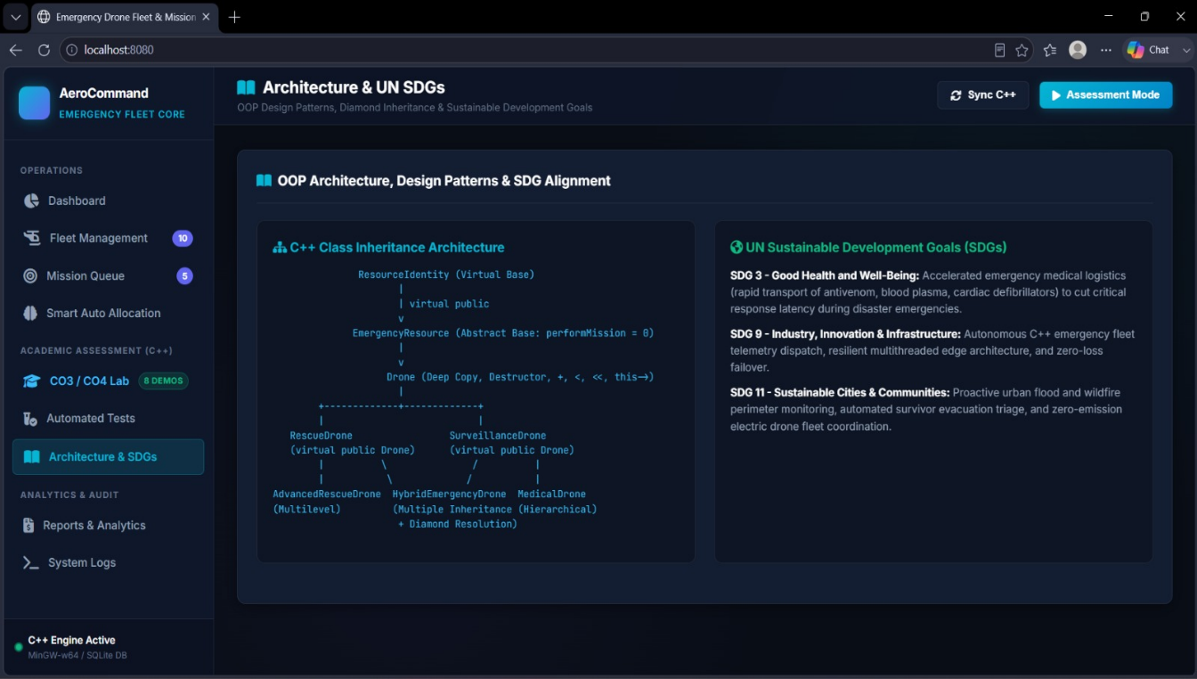

Task 2 – Emergency Mission Registration
The system provides a dedicated Register Emergency Mission interface for creating new emergency missions.
The user can enter:
- Mission ID
- Mission Title
- Mission Type
- Emergency Priority
- Deployment Location / GPS Coordinates
- Required Payload
- Required Range
- Estimated Duration
For example, a critical rescue mission can be created with a required payload of 8 kg, required range of 30 km, and estimated duration of 1.5 hours.
After registration, the mission is added to the emergency mission queue.
Figure: Register Emergency Mission
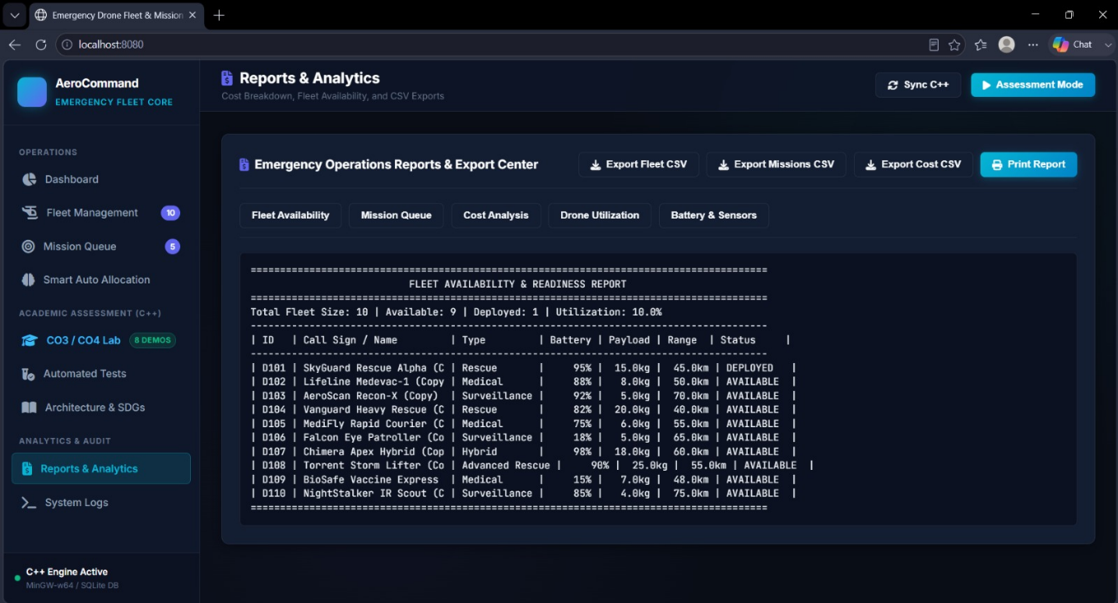

Task 3 – Emergency Mission Queue
The Mission Queue provides a complete view of pending and completed emergency missions.
The implementation displays:
- Mission ID
- Mission title
- Mission type
- Location
- Priority
- Required payload
- Required range
- Estimated duration
- Estimated cost
- Mission status
- Assigned drone
The system supports different priority levels such as:
- Critical
- High
- Medium
- Low
The screenshot shows examples such as flood survivor evacuation, emergency antivenom transport, wildfire thermal perimeter mapping, mountain hiker extraction, disaster relief first-aid delivery, and coastal storm monitoring.
This allows emergency missions to be monitored and prioritized systematically.
Figure: Emergency Mission Queue 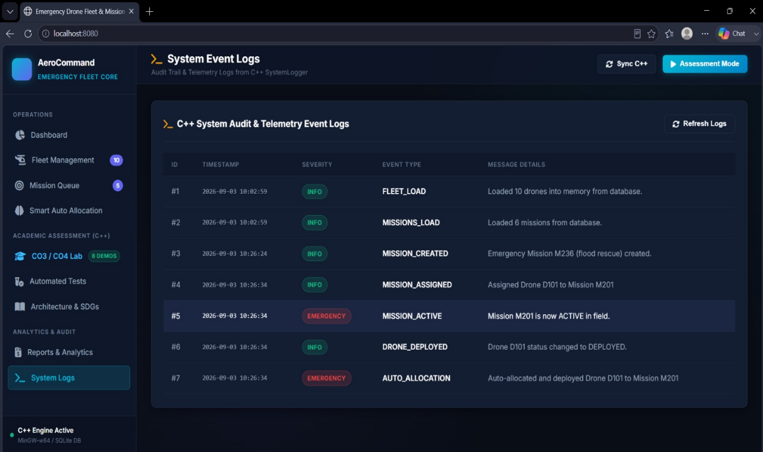

Task 4 – Smart Auto Allocation
The Smart Auto Allocation module is one of the important functional components of the system.
When an emergency mission requires a drone, the system evaluates available fleet resources based on mission requirements.
The allocation process considers parameters such as:
- Drone availability
- Battery level
- Payload capacity
- Operating range
- Drone specialization
- Mission priority
A suitable drone is selected and assigned to the mission.
For example, the system log demonstrates an automatic allocation operation in which a drone is assigned and deployed to an emergency mission.
The system then updates the drone status from AVAILABLE to DEPLOYED and records the operation in the system event log.

Task 5 – C++ OOP Architecture
The C++ architecture uses a hierarchical class structure to represent different types of emergency drones.
The base emergency-resource class provides common functionality while derived classes provide specialized behavior.
This architecture demonstrates:
- Abstraction
- Inheritance
- Hierarchical inheritance
- Multilevel inheritance
- Multiple inheritance
- Virtual inheritance
- Polymorphism
Figure: C++ Class/Inheritance Architecture
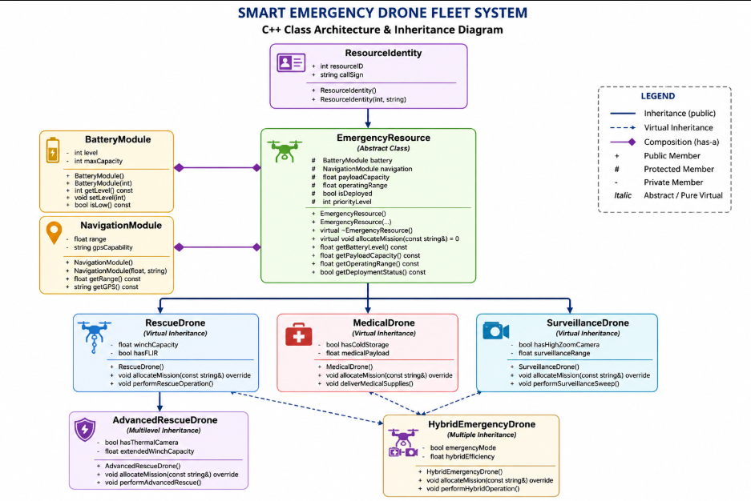

Task 6 – Runtime Polymorphism
The system uses virtual functions to allow different drone types to perform their specialized operations.
A common base-class interface can be used to handle different drone objects.
Conceptually:
C++
EmergencyResource* drone;

drone = new RescueDrone(...);

drone->allocateMission(...);
The function executed depends on the actual object type rather than only the pointer type.
This demonstrates runtime polymorphism and allows the system to support different drone types without creating separate processing logic for every drone.

Task 7 – Multiple and Virtual Inheritance
The Hybrid Emergency Drone demonstrates multiple inheritance.
Conceptually:
C++
class HybridEmergencyDrone :
public RescueDrone,
public SurveillanceDrone
{
// Hybrid functionality
};
Since both parent classes originate from the common emergency-resource hierarchy, virtual inheritance is used to prevent duplicate base-class data.
This avoids the diamond problem and ensures that a hybrid drone represents one physical drone with a single identity and common resource information.

Task 8 – Reports and Analytics
The Reports & Analytics module provides operational information about the entire emergency drone fleet.
The Fleet Availability and Readiness Report displays:
- Total fleet size
- Available drones
- Deployed drones
- Fleet utilization
- Drone ID
- Callsign
- Drone type
- Battery
- Payload
- Range
- Status
The screenshot shows a fleet size of 10 drones, with 9 available and 1 deployed, resulting in a displayed utilization of 10.0%.
The module also provides separate sections for:
- Fleet Availability
- Mission Queue
- Cost Analysis
- Drone Utilization
- Battery & Sensors
The system supports CSV export for fleet, mission, and cost information and also provides a Print Report option.
Figure: Emergency Operations Reports & Export Center

Task 9 – System Event Logging
The System Logs module maintains an audit trail of operations performed by the system.
The implementation records information such as:
- Event ID
- Timestamp
- Severity
- Event Type
- Message Details
Examples from the implementation include:
FLEET_LOAD
MISSIONS_LOAD
MISSION_CREATED
MISSION_ASSIGNED
MISSION_ACTIVE
DRONE_DEPLOYED
AUTO_ALLOCATION
For example:
MISSION_CREATED
Emergency Mission M236 created.

MISSION_ASSIGNED
Assigned Drone D101 to Mission M201.

MISSION_ACTIVE
Mission M201 is now ACTIVE in field.

DRONE_DEPLOYED
Drone D101 status changed to DEPLOYED.

AUTO_ALLOCATION
Auto-allocated and deployed Drone D101 to Mission M201.
This provides traceability for important emergency operations.
Figure: C++ System Audit & Telemetry Event Logs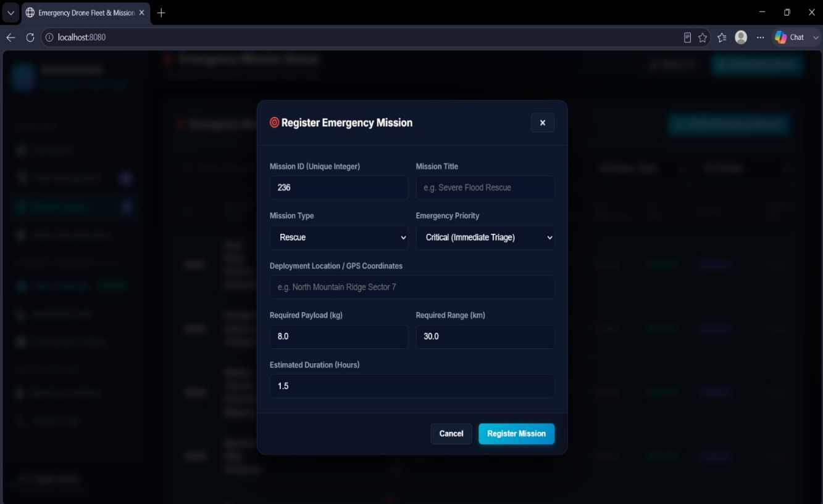
6. Testing
The system was tested using different operational scenarios to verify that the fleet management, mission management, allocation, database, reporting, and logging functions work correctly.
Test Case 1 – Drone Registration
A new drone was entered through the Register New Fleet Drone interface.
The system accepted the drone ID, model, specialization, battery, payload, and range and added the drone to the fleet.
Result: Successful.

Test Case 2 – Emergency Mission Registration
A new emergency mission was created by entering mission ID, title, mission type, priority, location, payload, range, and duration.
Result: Mission successfully created and added to the mission queue.

Test Case 3 – Mission Assignment
A suitable drone was assigned to a pending emergency mission.
The mission status and drone assignment were updated accordingly.
Result: Successful.

Test Case 4 – Automatic Drone Allocation
The Smart Auto Allocation function evaluated available drones and assigned an appropriate drone to an emergency mission.
The corresponding operation was also recorded in the System Event Logs.
Result: Successful.

Test Case 5 – Drone Deployment
After assignment, the drone status was changed to DEPLOYED.
The System Logs module recorded the deployment event.
Result: Successful.

Test Case 6 – Fleet Report
The Reports & Analytics module generated the fleet availability and readiness report.
The report correctly displayed the total fleet, available drones, deployed drones, utilization, battery, payload, range, and status.
Result: Successful.

Test Case 7 – System Logging
Important operations such as fleet loading, mission creation, mission assignment, activation, deployment, and automatic allocation were verified in the System Logs module.
Result: Successful.

Test Case 8 – Database Synchronization
The Sync C++ functionality was used to synchronize information between the C++ engine and the web application.
Result: Data displayed correctly after synchronization.

7. Reflection
Design Choices
The major design decision was to separate common drone characteristics from specialized drone behavior.
Common properties such as identity, battery, payload, range, and deployment state are handled at the resource level, while specialized drone classes provide their own operational behavior.
The use of inheritance makes it possible to extend the system with additional drone types without redesigning the entire application.
Composition is used for supporting components such as battery and navigation functionality because a drone has a battery and navigation module, rather than being a type of battery or navigation system.

Object-Oriented Design
The project helped demonstrate how theoretical C++ concepts can be combined into a practical application.
Instead of implementing each drone as an independent structure, the system uses a common object-oriented hierarchy.
This improves:
- Code organization
- Reusability
- Maintainability
- Extensibility
- Runtime flexibility

Smart Allocation
The Smart Auto Allocation module reduces the need for manual drone selection during emergency situations.
The system considers operational constraints such as battery, payload, range, specialization, and availability before assigning a drone.
This makes the allocation process more systematic and reduces the possibility of assigning an unsuitable or unavailable drone.

Database Integration
The integration of the C++ engine with SQLite provides persistent storage for fleet and mission information.
The web interface provides a convenient way to interact with the underlying C++ system while the database maintains the operational data.
This combination makes the project more realistic than a standalone console-based C++ program.

Monitoring and Logging
The System Logs module provides an audit trail of important operations.
This is useful because emergency systems require visibility into what happened, when it happened, and which drone or mission was involved.
The logs also make the system easier to demonstrate and debug.

Reports and Analytics
The reporting module provides a summarized view of fleet readiness and mission operations.
Information such as fleet utilization, battery level, payload, range, cost, and deployment status can help an operator understand the current state of the emergency fleet.

SDG Relevance
The project is mainly aligned with:
SDG 3 – Good Health and Well-Being
Medical drones can support rapid transportation of emergency medical supplies such as antivenom and other critical resources.
SDG 9 – Industry, Innovation and Infrastructure
The project demonstrates the use of C++, database technology, automation, and intelligent resource management to create an emergency-response infrastructure system.
SDG 11 – Sustainable Cities and Communities
Emergency drone coordination can support disaster monitoring, rescue operations, wildfire surveillance, flood response, and emergency delivery, contributing to safer and more resilient communities.
Figure: Architecture & UN Sustainable Development Goals
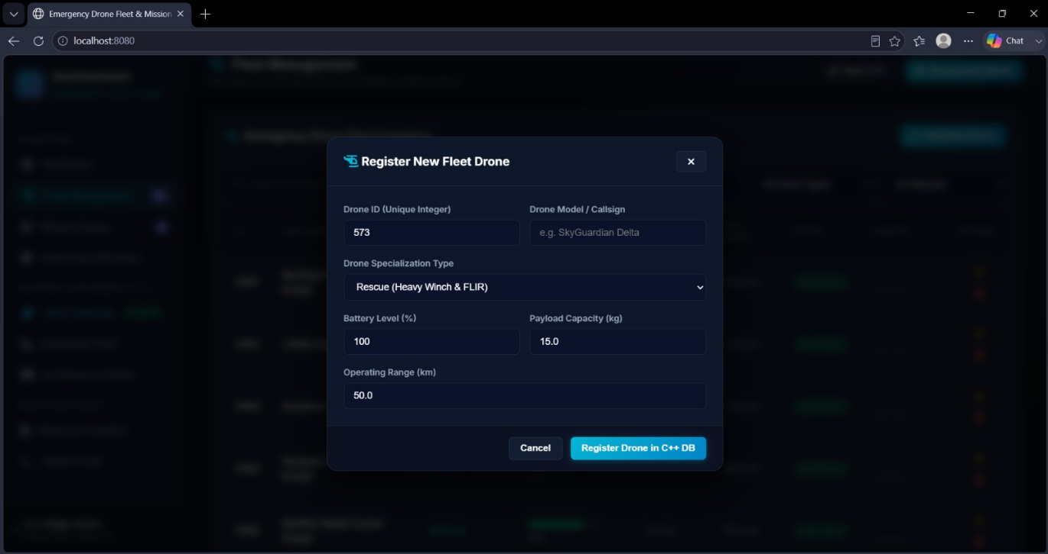
8. GitHub Repository
Repository Link:
[https://github.com/viji243/DSA0106-C-.git]
The repository contains the C++ source code, database-related components, web interface, configuration files, and project documentation.
9. MAIN DASHBOARD
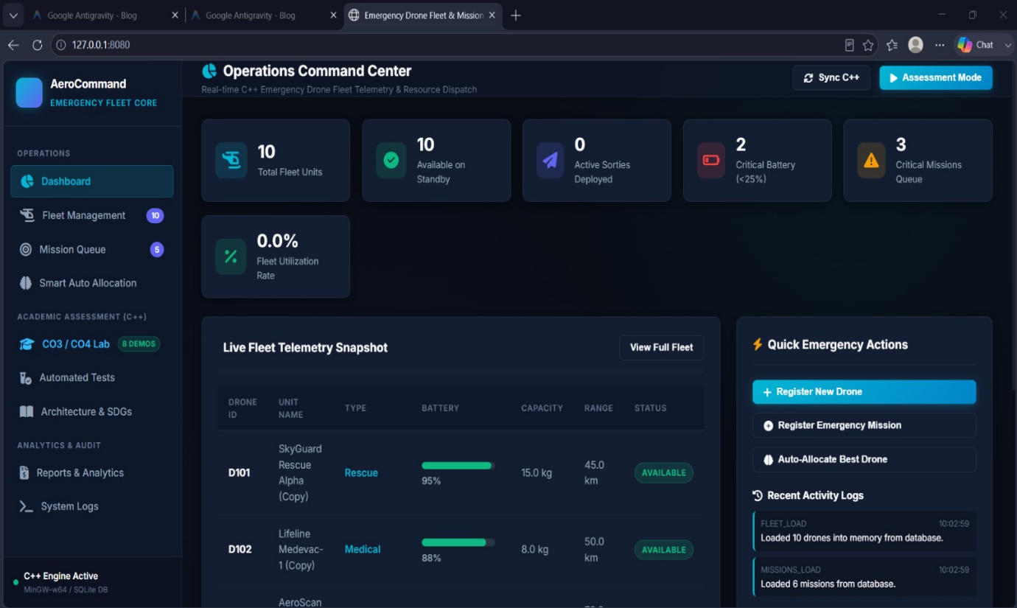

10. One-Page Individual Reflection
Individual Contribution – MEMBER 1
I mainly worked on the core system structure, fleet management, database integration, and reporting components of the Smart Emergency Drone Fleet and Mission Management System. My contribution included working with the C++ backend structure and maintaining the basic information required for emergency drones.
I worked on handling drone details such as Drone ID, model/callsign, specialization type, battery level, payload capacity, operating range, and deployment status. I also contributed to the Fleet Management module, including the registration of new drones and displaying fleet availability and readiness information.
Another important part of my contribution was working with C++ object-oriented concepts such as classes, constructors, destructors, encapsulation, composition, dynamic memory management, and database-related operations. I also contributed to the Reports & Analytics module, where fleet availability, utilization, battery, payload, range, and drone status are displayed.
Through this project, I gained a better understanding of how C++ OOP concepts can be applied to a real-world emergency management system. I also learned how a C++ backend can work together with a database and web interface to provide a complete fleet management application.

Individual Contribution – MEMBER 2
I mainly worked on the drone inheritance hierarchy, specialization, polymorphism, and mission management components of the Smart Emergency Drone Fleet and Mission Management System.
I worked with different drone categories such as Rescue Drone, Medical Drone, Surveillance Drone, Advanced Rescue Drone, and Hybrid Emergency Drone. I contributed to implementing important C++ concepts including single inheritance, hierarchical inheritance, multilevel inheritance, multiple inheritance, virtual inheritance, abstract classes, pure virtual functions, function overriding, and runtime polymorphism.
I also contributed to the Emergency Mission Queue, where emergency missions are maintained with details such as mission ID, mission type, location, priority, required payload, required range, estimated duration, cost, status, and assigned drone.
Another part of my contribution was implementing and testing the Smart Auto Allocation functionality. The system evaluates drone availability and mission requirements to support suitable drone assignment and deployment.
Through this project, I gained practical knowledge of how inheritance and polymorphism can be used in a real-world application. I also understood how different drone specializations can be represented through an organized C++ class hierarchy.

Individual Contribution – MEMBER 3
I mainly worked on the Smart Auto Allocation, system monitoring, event logging, testing, and user interface components of the Smart Emergency Drone Fleet and Mission Management System.
I contributed to the Smart Auto Allocation module, which helps assign an appropriate available drone to an emergency mission based on factors such as mission priority, drone specialization, battery level, payload capacity, operating range, and deployment status.
I also worked on the System Event Logs module. The system records important events such as fleet loading, mission loading, mission creation, mission assignment, mission activation, drone deployment, and automatic allocation. This provides an audit trail that helps operators monitor the activities performed by the system.
In addition, I contributed to testing the different modules and verifying that the web interface correctly displays information received from the C++ engine and database. I also helped verify mission registration, drone registration, allocation, deployment, reporting, and synchronization features.
Through this project, I gained a better understanding of system integration, automated resource allocation, database-backed applications, event logging, and testing. Working on this project helped me understand how C++ concepts can be integrated with a web-based interface to develop a practical emergency response management system.

